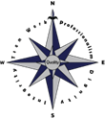
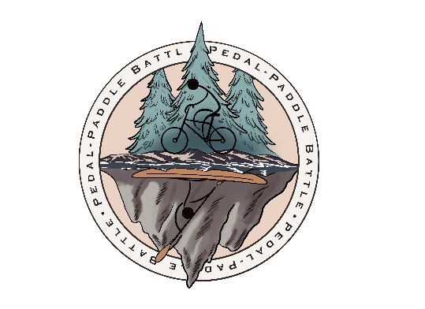

Peterburg Medical Center Foundation
2023 Pedal/Paddle Battle Sponsorship Form
All donations will go directly to the PMC Foundation to support continuing education and scholarships for PMC staff and high school graduates. All donors who provide their mailing address will receive a tax-deductible donation receipt following the event. The drawing will be held at the Pedal/Paddle Battle BBQ at the finish on Saturday July 29th, 2023.
Instructions: Participants are encouraged to collect donations/sponsorships to help support the PMC Foundation. Log all donations you collect on this form, regardless of payment method. Turn in all cash and checks at registration on July 29th, 2023. You will earn one entry into the drawing for every donation you receive ($25 or more)!
- Cash/Checks Donations:
  - Make checks payable to “Petersburg Medical Center Foundation”
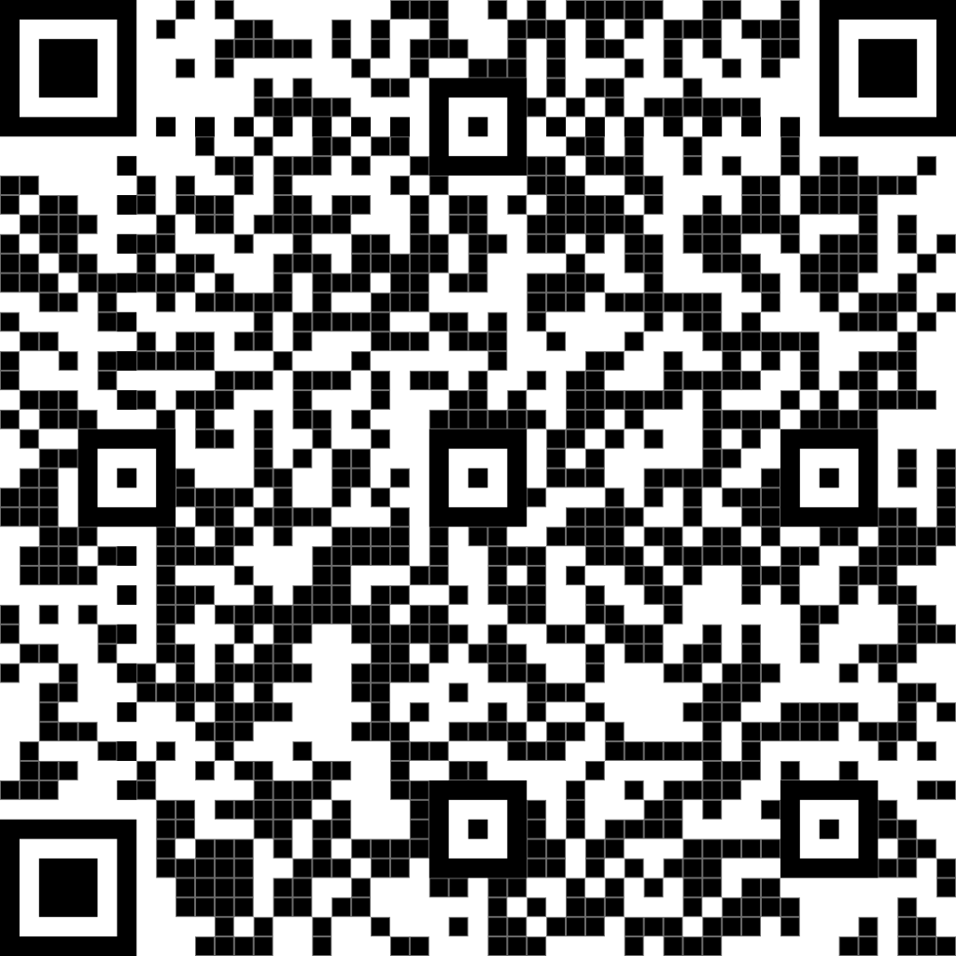
  - All cash and checks must be collected and turned in at registration (or prior) to have your sponsors and yourself entered into the drawing!
- Online Donations:
  - Have your sponsors donate online (paypal or credit card) by going to: https://www.pmcak.org/donate1.html (or scan WR code )
  - Select Pedal/Paddle Battle Donation on top left
  - Be sure they enter your name when donating so you get credit
  - Use this link to share online with your friends!
Pedal/Paddle Battle Drawing: Tell your potential donors about our great prize giveaways! Participants and sponsors will be entered into the same drawing. You could win just by making an ask or your sponsors could win just by donating!
- Prize Giveaways:
  - AK Airlines- 2 Roundtrip Tickets
  - Kayak - Old Town Vapor 10ft sit-inside
  - Puffer Blanket – Rumpl outdoor packable blanket
- How to Enter Drawing
  - Participants: Earn 1 entry for registering + 1 entry per sponsorship you get (minimum $25)!
  - Sponsors: Earn entries based on your sponsorship level:
    - Donate $25 = 1 entry
    - Donate $50 = 3 entries (1.5 times the entries)
    - Donate $75 = 9 entries (3x the entries)
    - Donate $100 = 15 entries (nearly 4x the entries!)
For Questions: Contact Julie Walker at 907-772-5552 or jwalker@pmc-health.org
2023 Pedal/Paddle Sponsorship Form
Donation Levels: $25 = 1 entry, $50 = 3 entries, $75 = 9 entries, $100 = 15 entries
ALL DONATIONS MUST BE HANDED IN BY JULY 29TH AT 11:00AM TO ENTER DRAWING

FULL NAME | DONATION AMT | CASH/CK/  ONLINE | EMAIL | MAILING ADDRESS | PHONE #

NOTE: Donation amounts below $25, above $100, or in-between levels will be entered according to structure above. (Examples: $20 donation would not be entered into the drawing, $40 donation would earn 1 entry, and $150 would earn 18 entries)

